Now click on open website button

Now when your website will be opened you will get the small window in corner when your website will be opened (maybe gecause of facebook code added in head or body section)

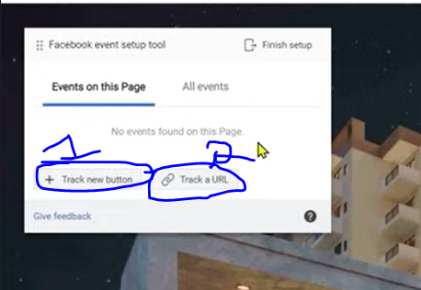

Now in your two option as above you can click on marked 1 to make abutton click as an event or you can click on marked 2 to track a url means when that url got hit then we call it as an event but here we are talking about

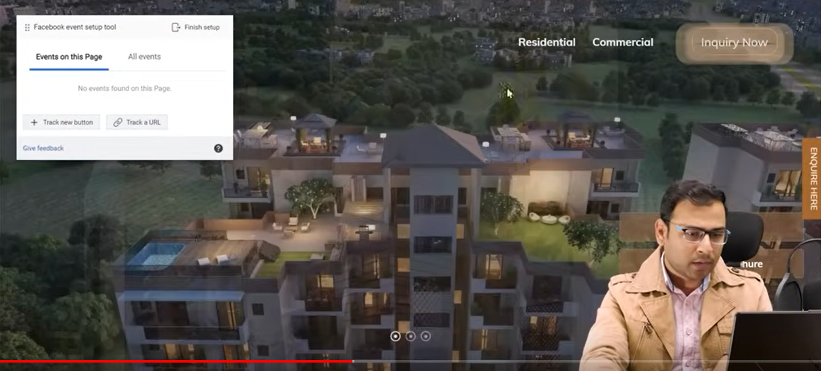

I think the Facebook has taken control of your website for temporary purpose so the button Inquiry now which we want to track is highlighting itself even all the buttons present in our site

Now when you click on marked in as marked in second last image then the side window will be removed and all the buttons are continuously highlighting itself. Click on any button to which you want your event associated

So if you click on any button

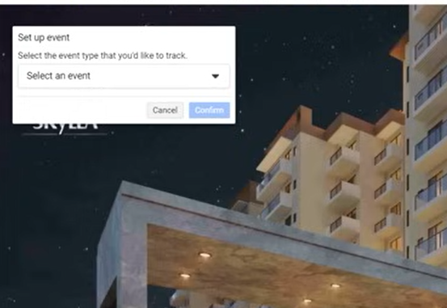

Then it will again open a corner window again like as shown in the image above

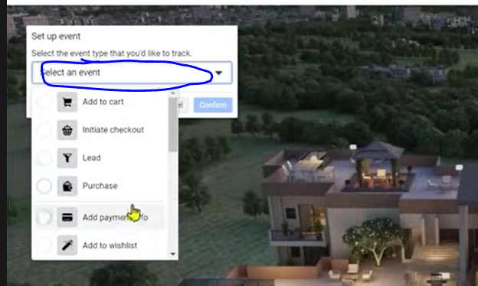

Now click on above marked area to show a submenu as shown above Now click on any option .Each option is a name which will be associated with your event

Now lets say we choose complete registration

And then click on confiem button present in corner window.

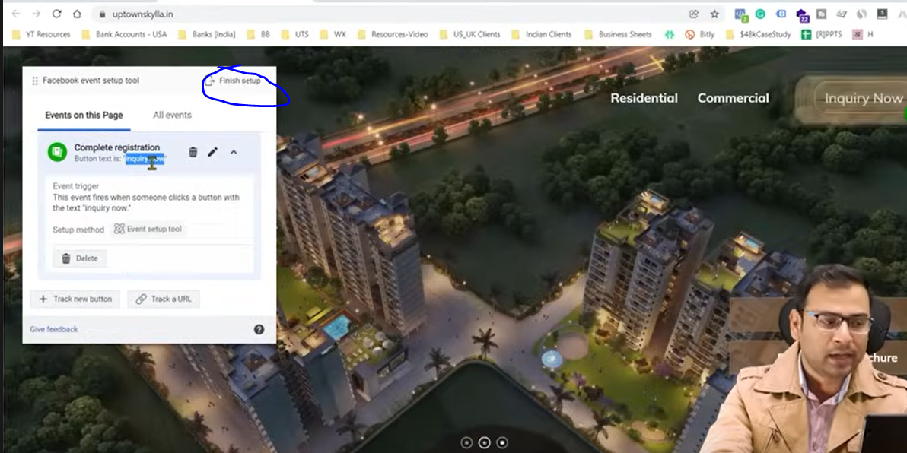

Now whenever someone click on the Inquiry button it will be counted as an event inside this pixel

Now click on Finish Setup as marked above

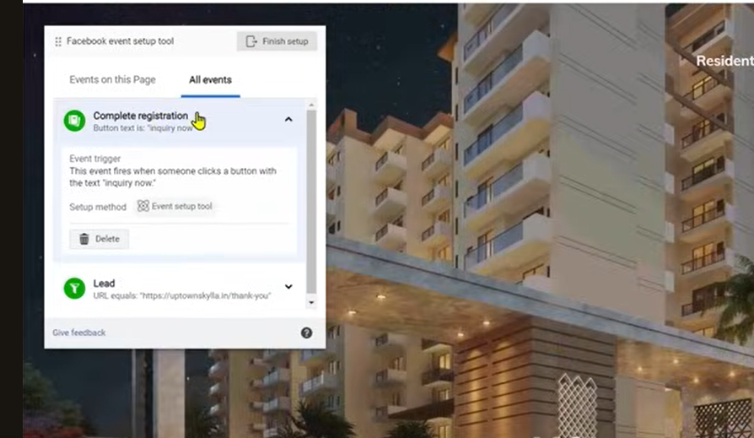

_______________________________________________________________

**Tip:-**

Now click on All event tab and can see all your events you can modify it or delete it.

_______________________________________________________________

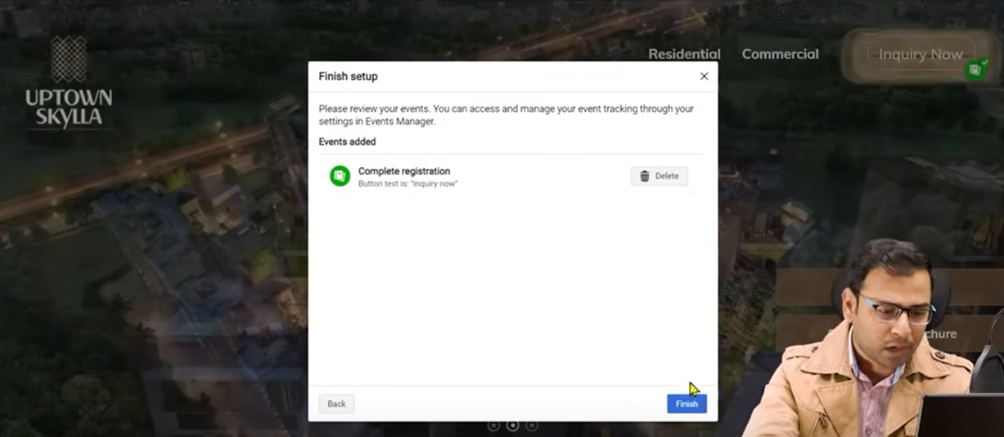

Now you will see a mini window in the center

Now click on Finish button.

Now it will ask you feedback you can give or not it all depends upon you

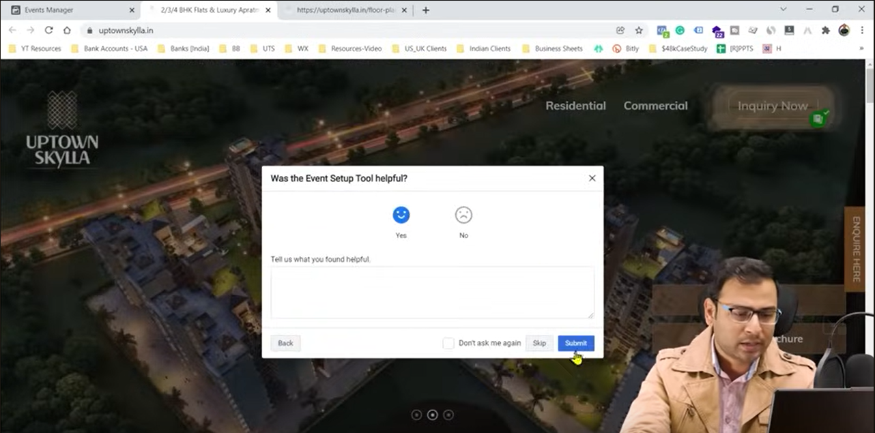

Now click on submit

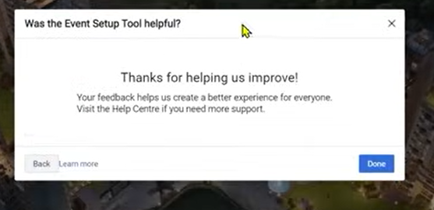

Now click on Done

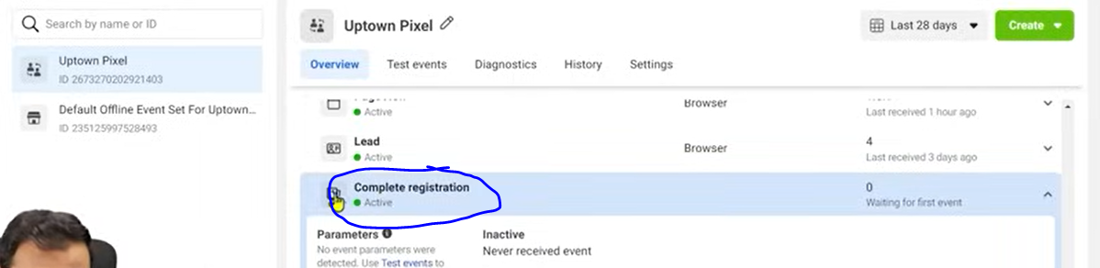

Now you can see the event we created listed as marked above

Click on the event to expand it

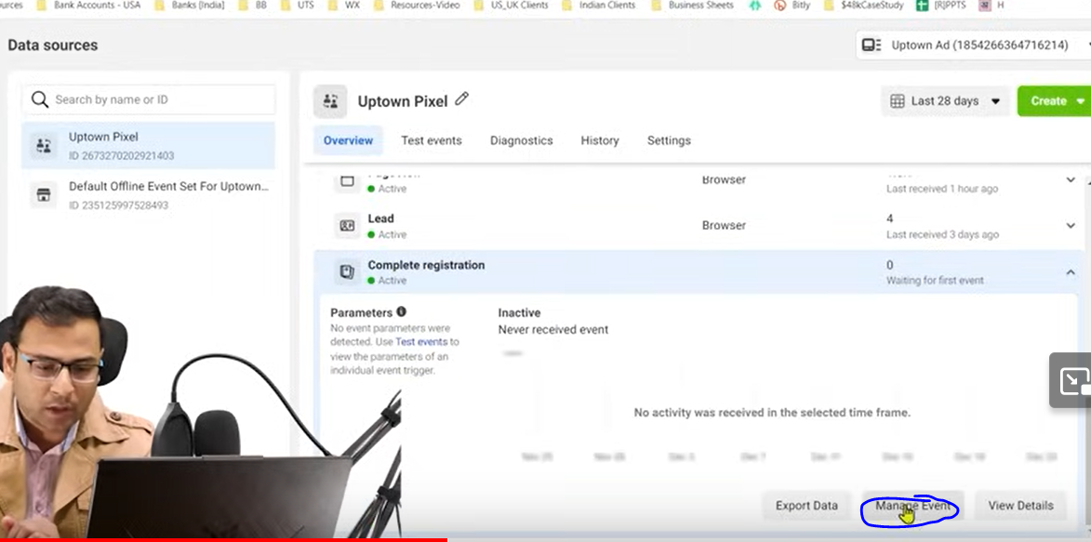

Now we will click on Manage event

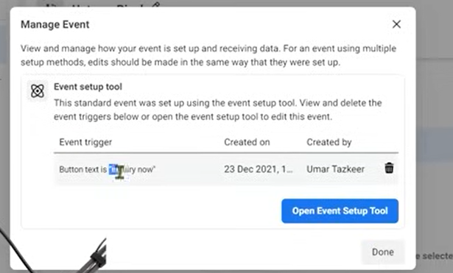

Then you can see when the event will be triggered It is saying when the button “Inquiry now” will be clicked

So by this event setup tool you can setup the event but it will only help you setting up very normal type of event

But when we need complicated event then we need to use GTM

Lesson 41:-

In this lesson we will learn about **Events and Custom Conversion**

Event help us to track the things like how man registration happened and it will help us to optimize everything

And we can create our report that how many event did get hit

Now there is another option if we go to custom conversion in side menu like below

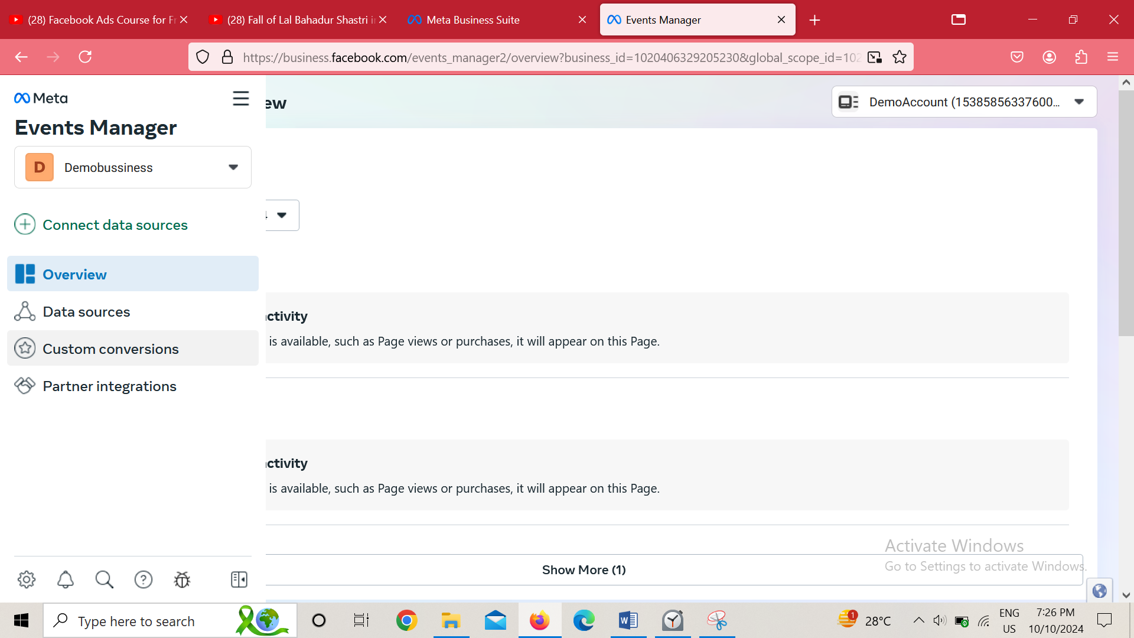

It will give us option to make custom conversion

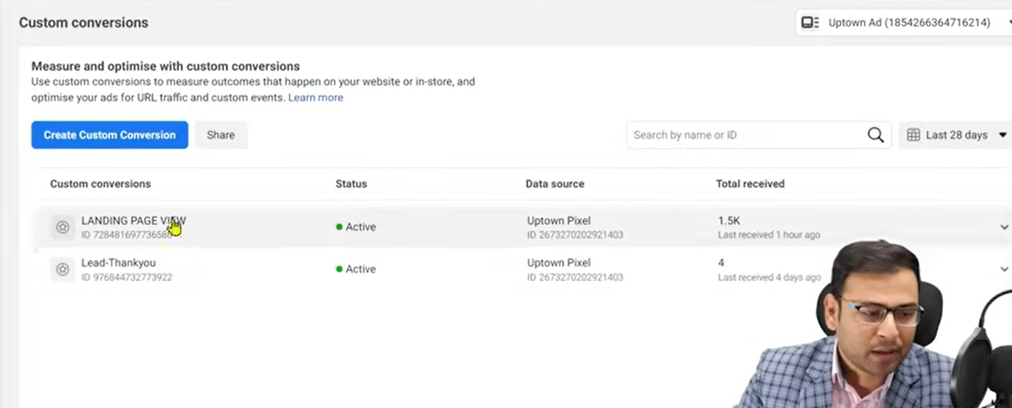

But if you open it fist then it will show this interface

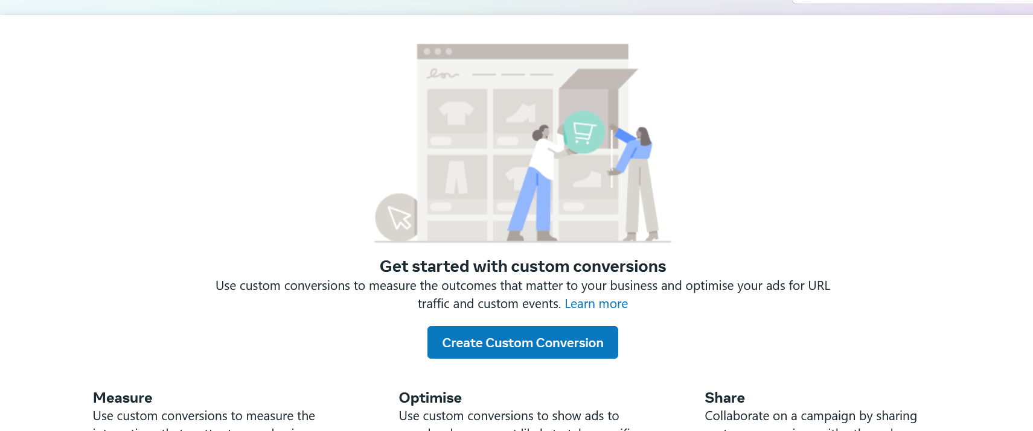

So either way click on Create custom conversion button  
and then a mini window will be opened in center like below

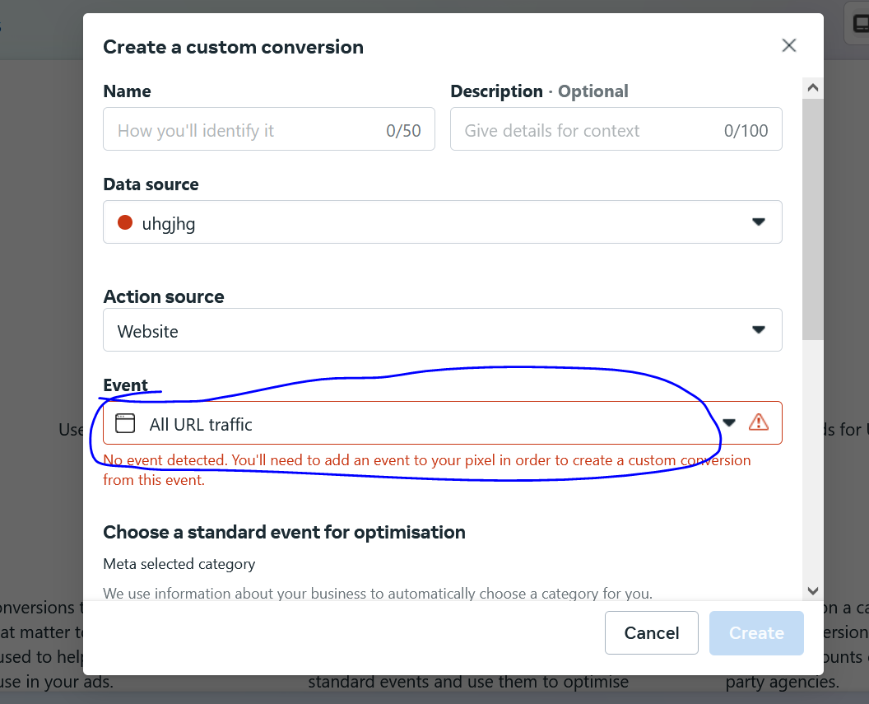

Here the above marked will make custom conversion of all the urls mentioned in the list as marked below

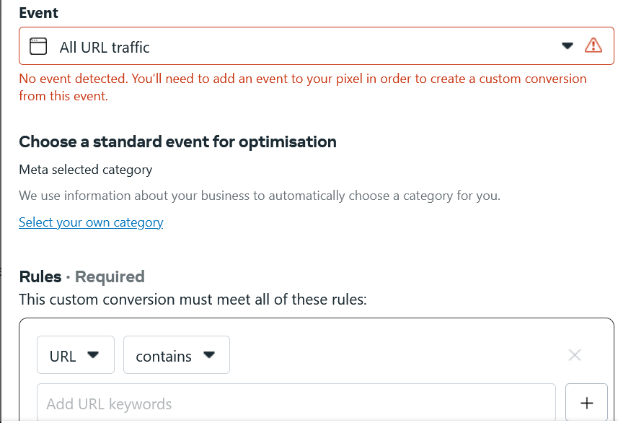

Suppose we type thank-you page url in the field then it will make convergence audience of those who will hit the url

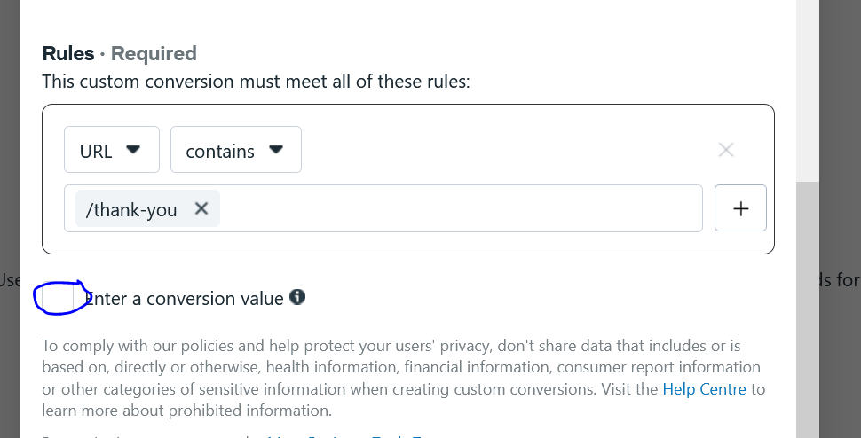

You can also click numeric value for each conversion by checking the marked checkbox. Now there appears a textfield below the checkbox.

But this same we aere doimng in events both of them are being used for tracking, Reporting and optimizing Campaigns by analyzing the event and know by running our campaign on the basis of this then we cn get high convergence

So what is the difference in them

Remember when the teacher went to make custom convergence we see that there is no need of code but if we want to create events then the standard event we have there is a code associated with them we have to fire them in our website in a specific condition.

Suppose I want to create a lead event then lead event has some condition

The condition is that if a thankyou page load in our website then lead as an event get triggered

So for the trigger we need some additional code that is called event pixel

We fire this code in this condition

Now as we know in previous example of previous lesson we did not use any code while making an event there teacher used event setup tool which is very user friendly but there is different option where we use the code and through the code we create the event

But whatever way we use what actually happens in backend is that one pixel is fired in certain condition and when that pixel is fired then we call that an event was triggered

So behind the events there are codes involved

But in convergence we did not need convergence

Events can be customized by the help of parameters means with event we can give any additional information

Lets take an example in which an event happened that is actually add to cart but whatever add to card happened is of product the that product must have parameters means product cost ,id so we call them parameters So through these parameters our event is formed

But if we talk about custom convergence there only url exist

On the basis of url you can make custom convergence.

So if event happens then we say convergence happened

But you cannot make a custom convergence without url

Suppose you want that if anyone is scrolling our website only 50 percent and we want to make it custom convergence you cannot do it technically for this first you have to set up events

First you will make an event then you will use it in custom convergence(who knows what teacher is saying

And then comes the point that there is more flexibility in event because there are different criteria to make events

Unlike custom convergence where we only use url

So there is limited flexibility in custom convergence

Remember on the basis of custom convergence custom audience cannot be created

So events are more powerful than custom coinvergence with regards to tracking

It provide event tracking in granuer level

Now we will see this thing practically

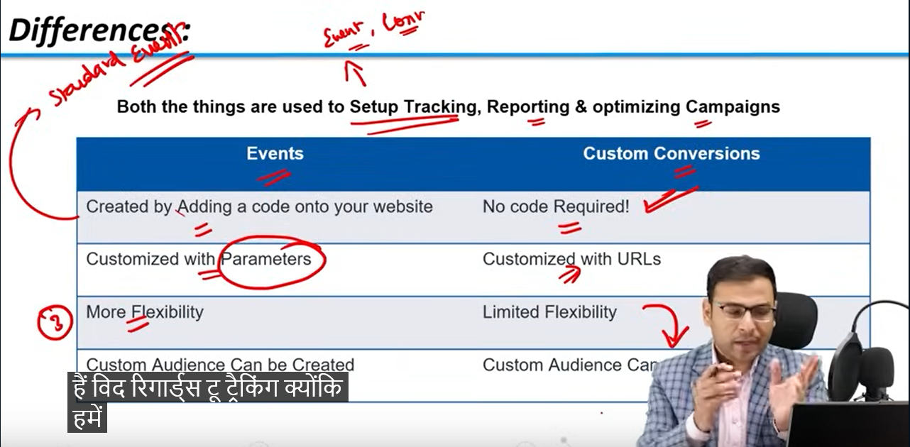

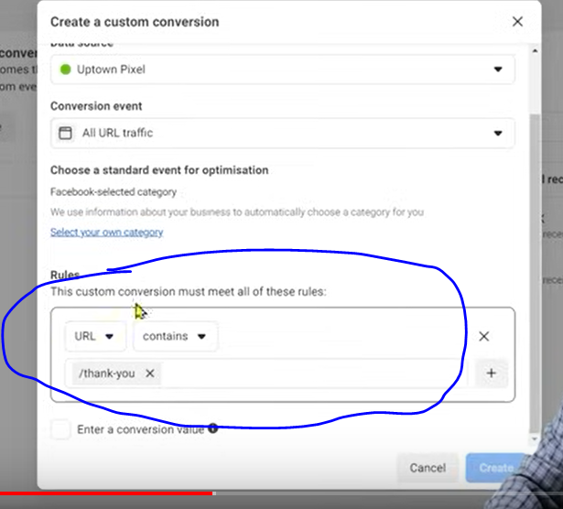

So you choose convergence event on the basis of rules as marked above

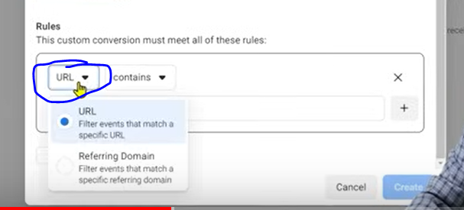

By click onmarked area above

You can choose url or Domain you want to add in your list’

Now in other hand if we want to create event then we will go to event manager because there our events will be made

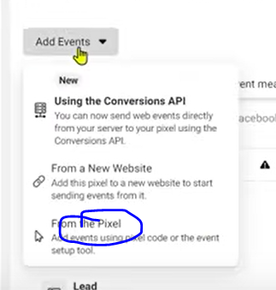

we choose add event and then chose From the pixel

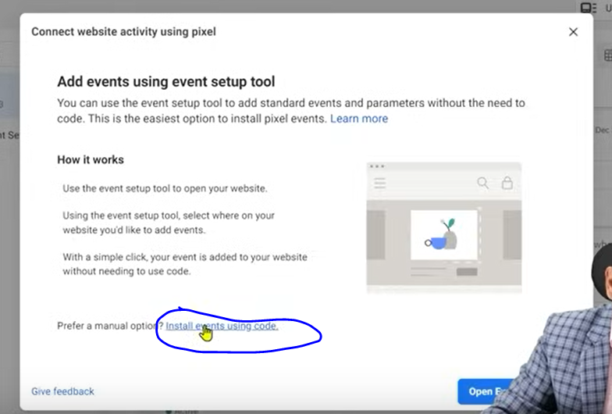

Ad then a mini window will open in the center Now click on the install events using code. Then in a new page different different option will be shown on the basis of what you can make events

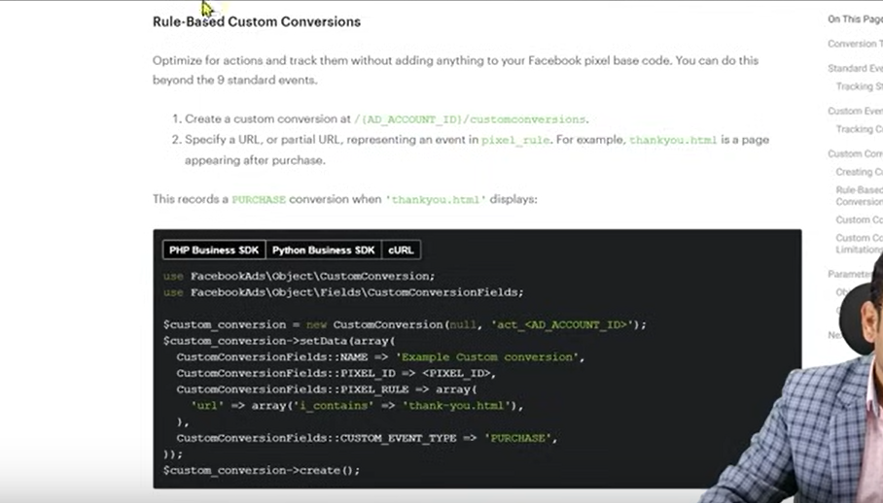

The above codes are those code which you have to fire on the fulfillment of the condition

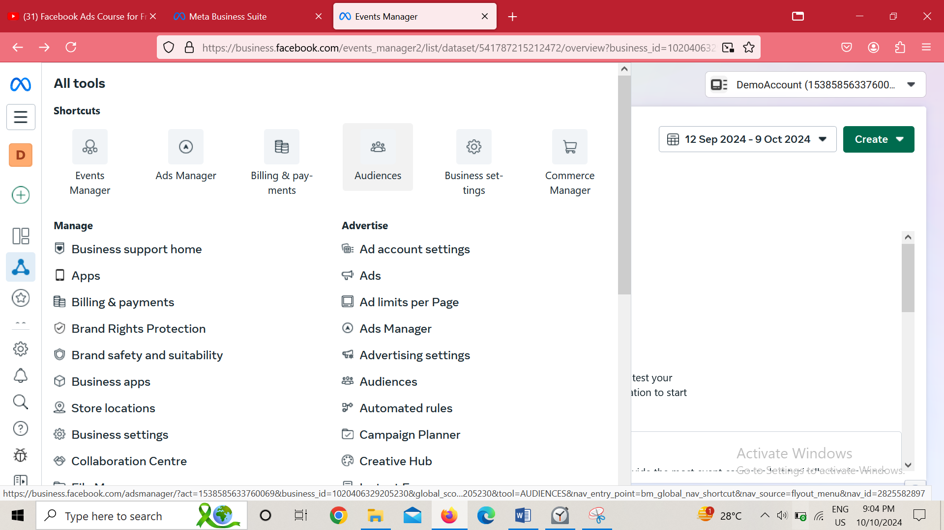

Now we will go to side menu and then to Audiences as shown in above screen

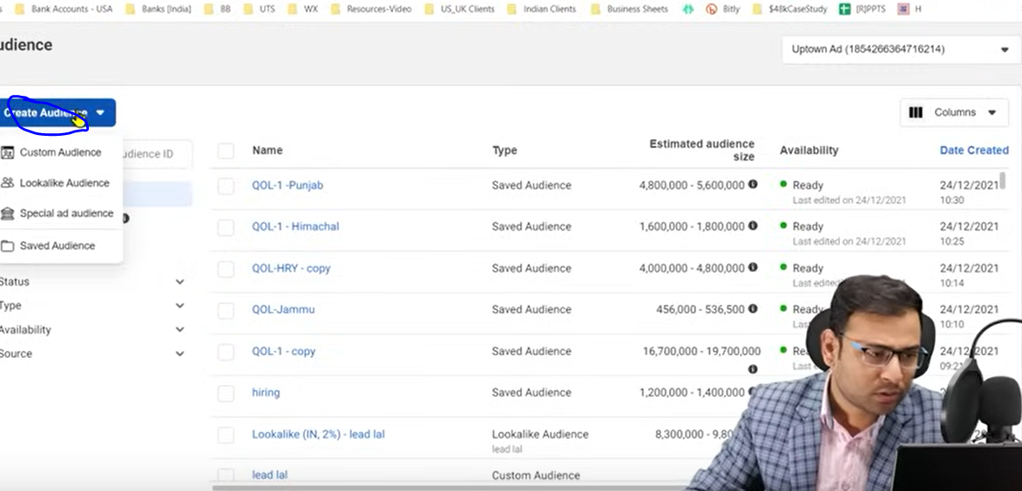

Now go to Create Audience button as marked above and then a submenu will open

Now in submenu go to Custom audience

If you are new you will see the screen like below

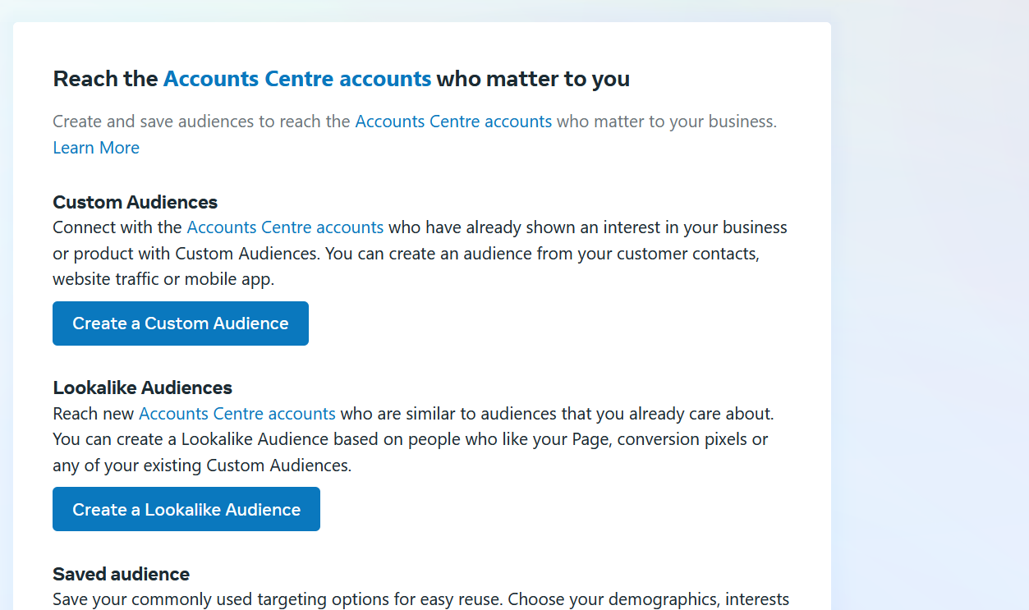

You can click on create Custom audience

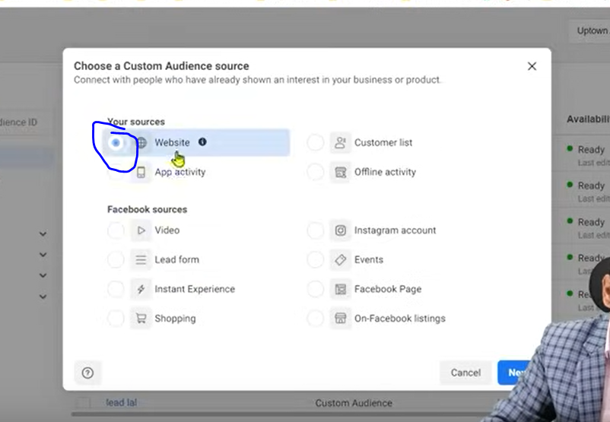

You will see window in the center of the screenand in above choose website as marked above and then click on next button

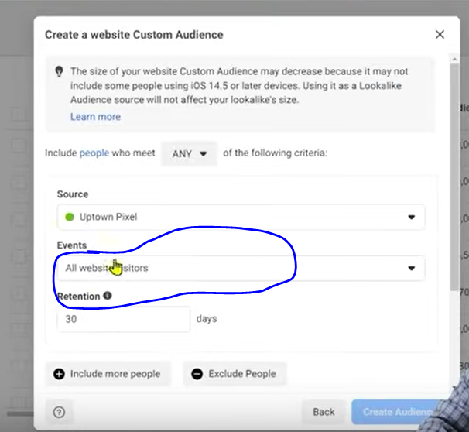

And then we will say we want to make an audience of those people who had done the custom convergence but you will not see it in the list but you will see event in the list if you click on marked above as shown below

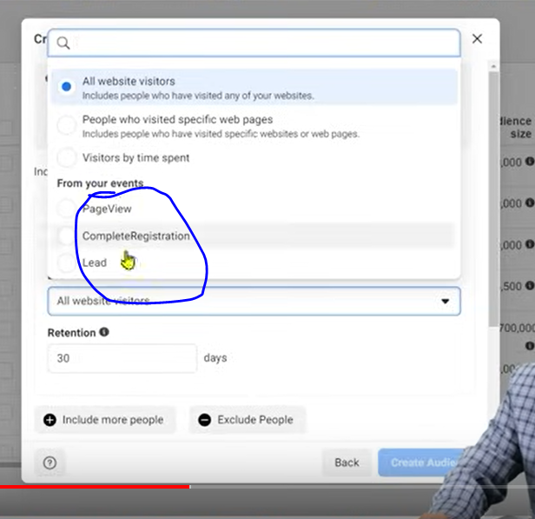

**Phase 55**

You can use features of custom convergence in events but ont vice versa

**Lesson 42:-**

In this lesson we will learn about **custom conversion in Facebook Ads**

In this lesson we will learn about how to setup custom convergence

Before setting up we need to understand why here we are talking about convergence

Why it is need ot be setup

If we don’t setup it then what potential we will miss

Lets take an example in which when we run campaign in facebook ads then there you will see different type of campaign which we call conversion campaign

Why we run it and what does it mean

It means you are saying to facebook system that I want to show my ad to those people who have high chances of convergence and then facebook try to show the ad to those people who have high chances of convergence Then the facebook will ask you what you consider convergence Basically we need to define convergence

We can make standard event and we will take them as a convergence and then we will optimize our campaign for our event

If we cannot do so by standard event then we have to do by custom convergence which are based on the url

So we assume we take a custom convergence condition that any one who visit the two pages of a website one by one we will take it a custom convergence

And now we want that our ad should be shown to those people whose characteristics match with the characteristics of visiting the two page

If we define a custom convergence and then after that from different different sources and then perform this custom convergence

And when someone do this custom convergence then the facebook system understand that this person come and he do this custom convergence and similarly hundereds of people come and they do the custom convergence so now facebook know there characteristics

And now I say to facebook that I want to run a convergence campaign and show my ad to those people who attributes match with these hundereds of people who have done custom convergence

So we understand that if we define custom convergence by our way then on the basis of custom convergence we can optimize our convergence campaign

Convergence campaign try to show the ad to those people whose characteristics match with those who have done custom convergence

So basically our convergence campaign is optimized for a specific conversion

So Teacher believe that you have understood our work is going on not becaue of standard event but of custom convergence because you cannot make condition in standard event like of visiting two consequtive url

What you can make standard event it is of clicking on a specific button and on the basis of that you can optimize your convergence campaign.

Or you can make an event of visiting a page

So you make an event of visiting thank you page as complete registration so on the basis of this event you can run convergence campaign

SO now we will try to make custpm convergence on the same condition of visiting two page consequently

So we will go to event manager and then go to custom convergence and then to create custom convergence now as usual a mini window will be opened Name it anything you want which match its purpose.

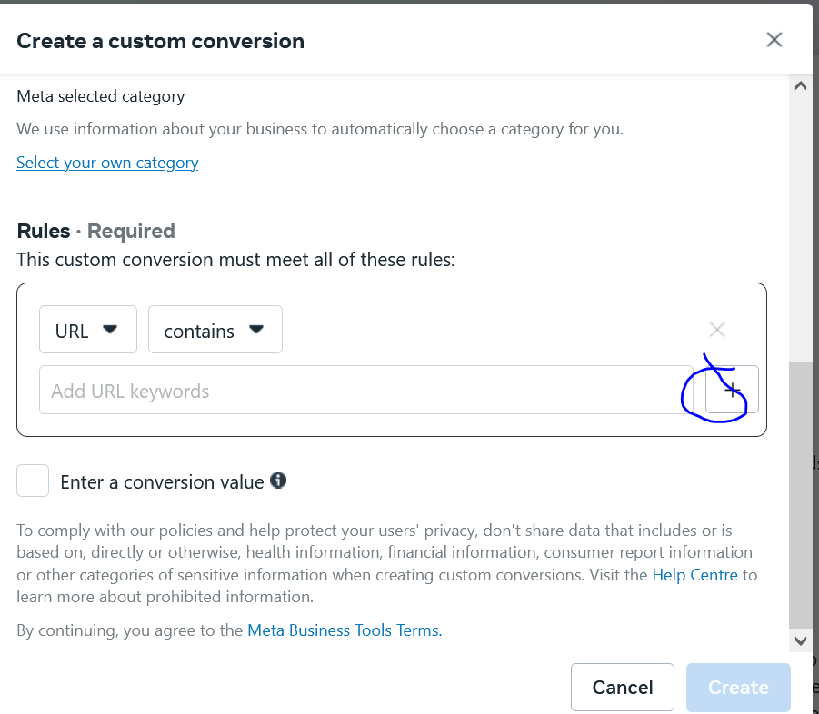

Now we type the url section and then click on + button beside it as marked above to add another URL

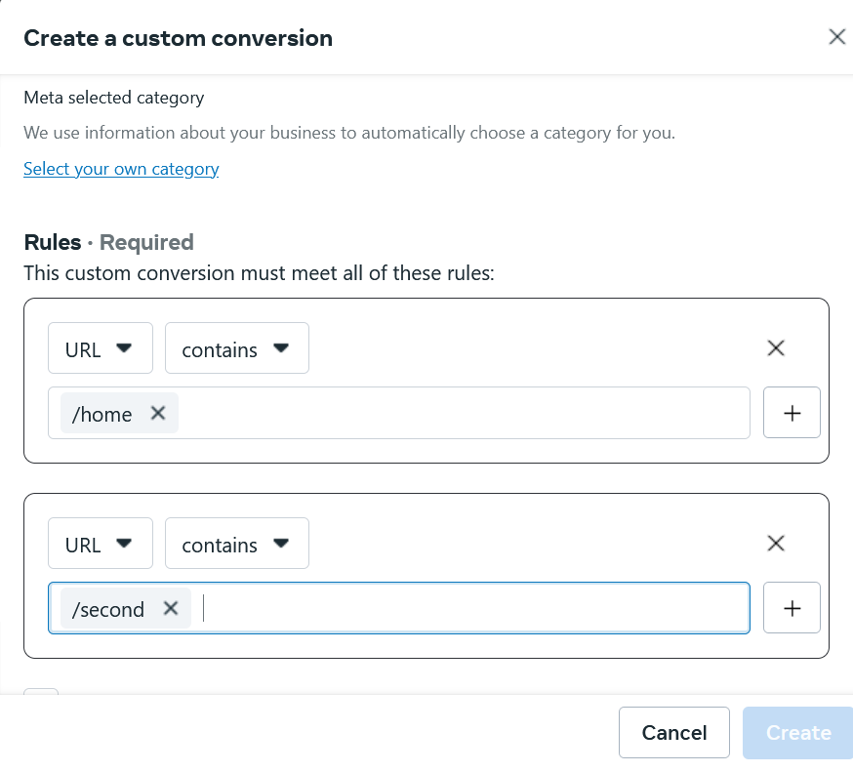

Now a second field will appear below first field

And both of these field above there it is written This custom conversion must meet all of these rules

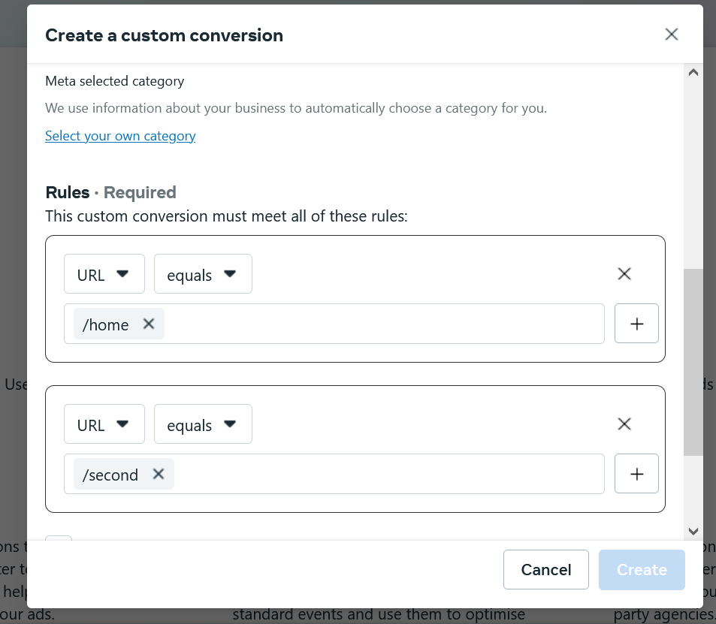

And each url has equals selected beside it.We can give monetory value to it about how to measure each conversion we will go ahead and create

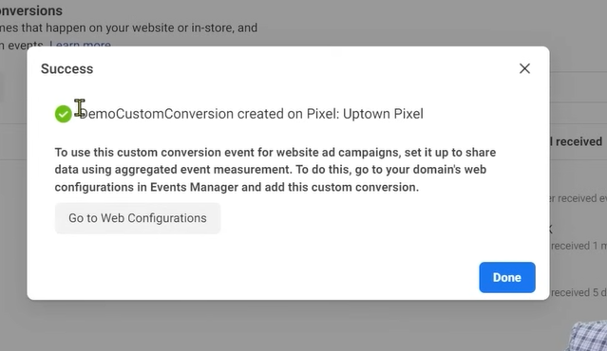

Now above dialog box will appear in the center

Teacher is not telling any priorityrelated thing which we will see in future

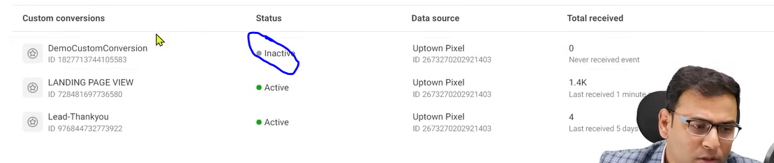

Now once you created it now you will see it is being shown as inactive as marked above

It is because this mean until this convergence does not get hit or happen. it will not show any activity

It will become active when the convergence happens many times

Once it becomes active

Now suppose we run a campaign and then we will reach adset level

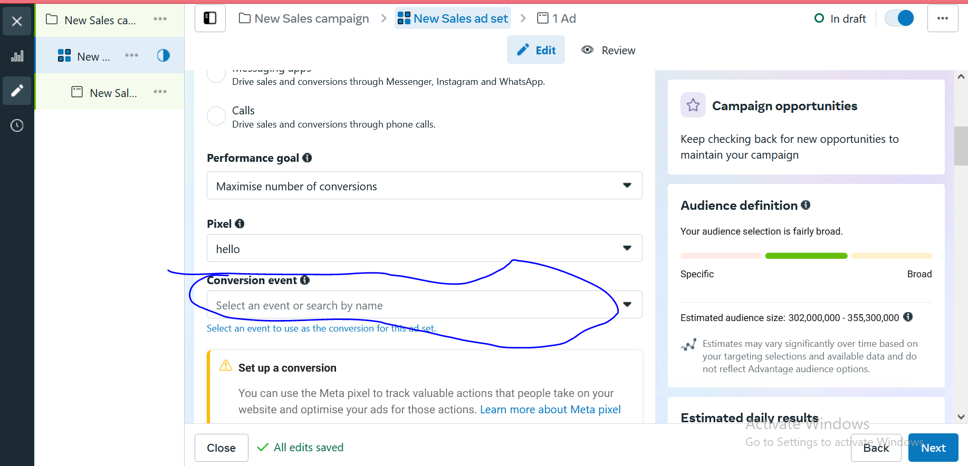

And then choose the pixel

And once you choose the pixel you want then below it a textfield will be shown of conversion event

When we go to conversion event then we get list like below

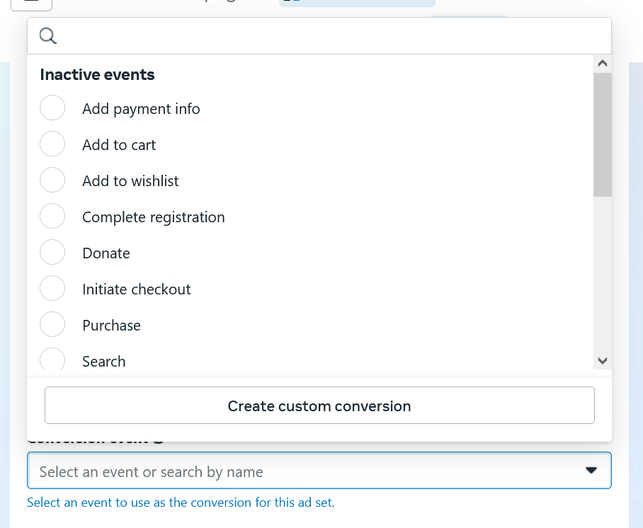

And it is dividing the list into inactive event or active event

We can optimize our campaign on the basis of active events

If these event does not happen in huge numbers then this campaign will not run in better way

Here you can see the inactive event we created.

**Phase 56**

I think You can also add event to custom convergence if your data source mentioned in custom convergence have an event associated with it

I think by this when that event will happen then the occurance of this custom convergence is counted and also it is counted when the url given got hit in the rules section so the event happens(who knows)

You can choose your event as marked below

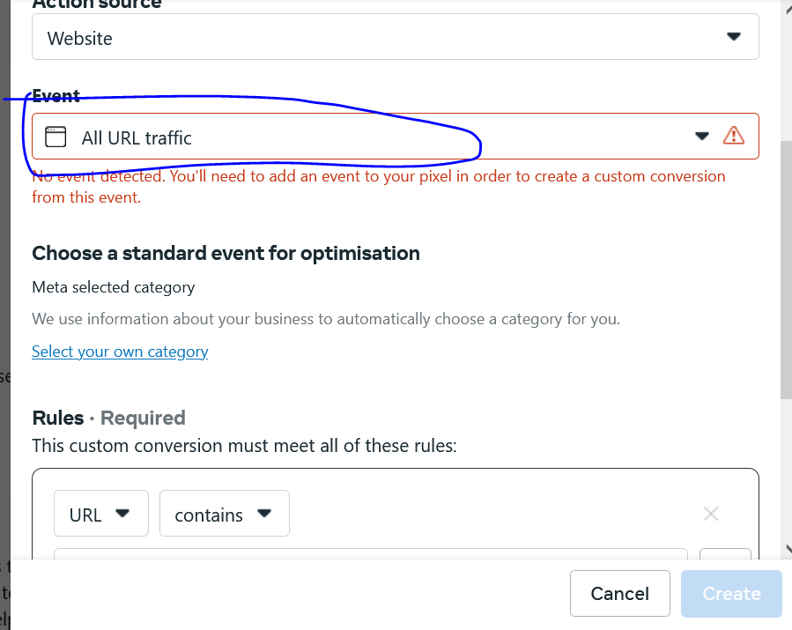

And in rules you will add url you will consider the event fulfillment and we can say custom convergence as will(who knows)

**Note:-**

Through GTM you can fire the pixel in different different situation

First we need to understand that how custom convergence is made

What is the work of custom convergence

Why do we made it

**Lesson 43:-**

In this course we will see **Custom audience in facebook audience**

We will see different ways to create custom audience in ad account

It is a very important because success of our campaign depend on it.

Because in starting you don’t have any option you just go for saved audience but as gradually your account become old and interaction on your website is started to increase or app then your custom audience increases and that custom audience perform in better way and you get good result from it.

And we also use it audience from remarketing point of view

So custom audience concept is very important In any advertising platform

We can create it in different different scenerios or cases.

We can create infifnite number of cases

For example we can make an cuatom audience of people who visited our website and stayed there for five minutes

People who gone to About us page or as well as Services page

Or whi has visited services page and scrolled 30 percent

Similarly we can do so for app

We will see different ways to make custom audience and what is required ot made it

And then we see ways to create different type of audience

The first way to create the custom audiences is by our own property like website

Website is not facebook owned by our facebook but by us We just need a pixel that facebook ad account give us if we put it in our website then the different interaction done by the user We can make custom audience on the basis of that interactionwe can also do so by android application

So first way is based on the basis of our property that is website

The second way is by using facebook properties or platforms

So we can make custom audience with the help of facebook platform

What are type they are of that is page

The facebook page we make is actually a facebook property

Similarly we can also say instagrm profile

Or if we run lead form in facebook

Or we have made a=some event in facebook

These things are facebook properties or we can say assets

WE can audience of the people who have liked our page

We want to make a custom audience of people who have interacted with any ad originated from the page (who knows may be interacted with ad shown in our page who knows)

In our first case we were trying to make custom audience on the basis of websote.

In second cae we are using facebook property or assets like pag, instagram profile, lead form, event

There is another way to create custom audiences

We can upload our customer list to make our custom audience . Lets say we have custom audience

Lets say we have some contact numbers , we have some names, email ids then on the basis of that we can make our audience, email ids

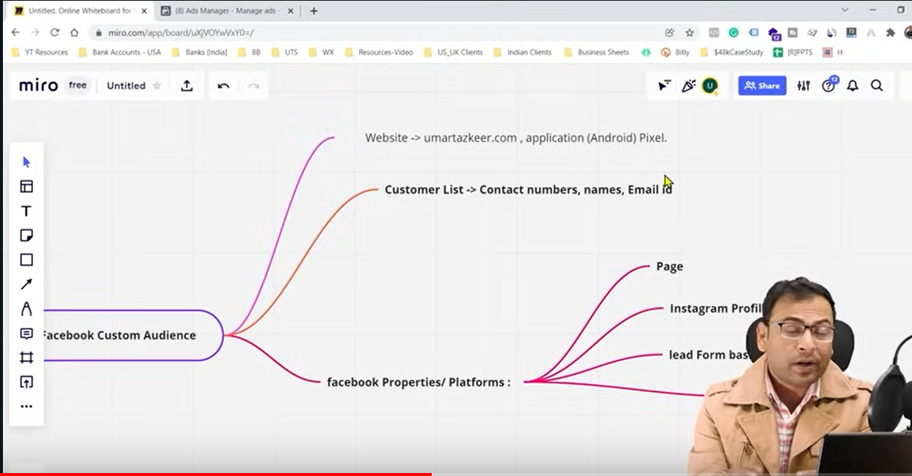

You can see all about your audience in the side menu al tools section as shown below

Click on the marked area to know all about your audiences

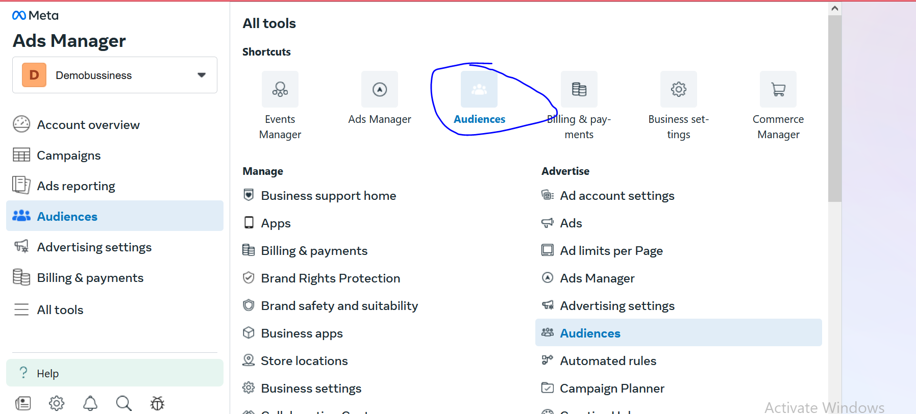

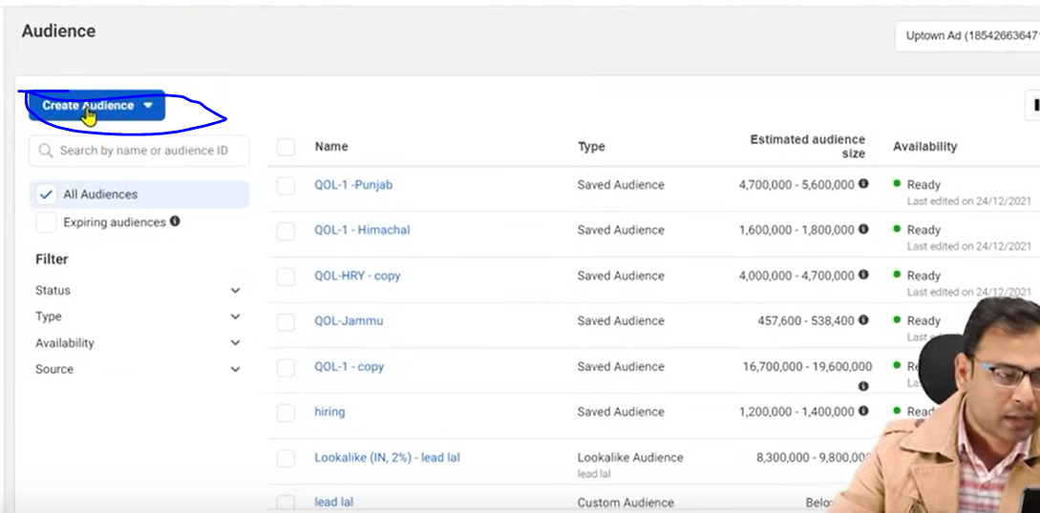

You can click on marked above to make a custom audiemce

But since we are new it will ahow something like below

‘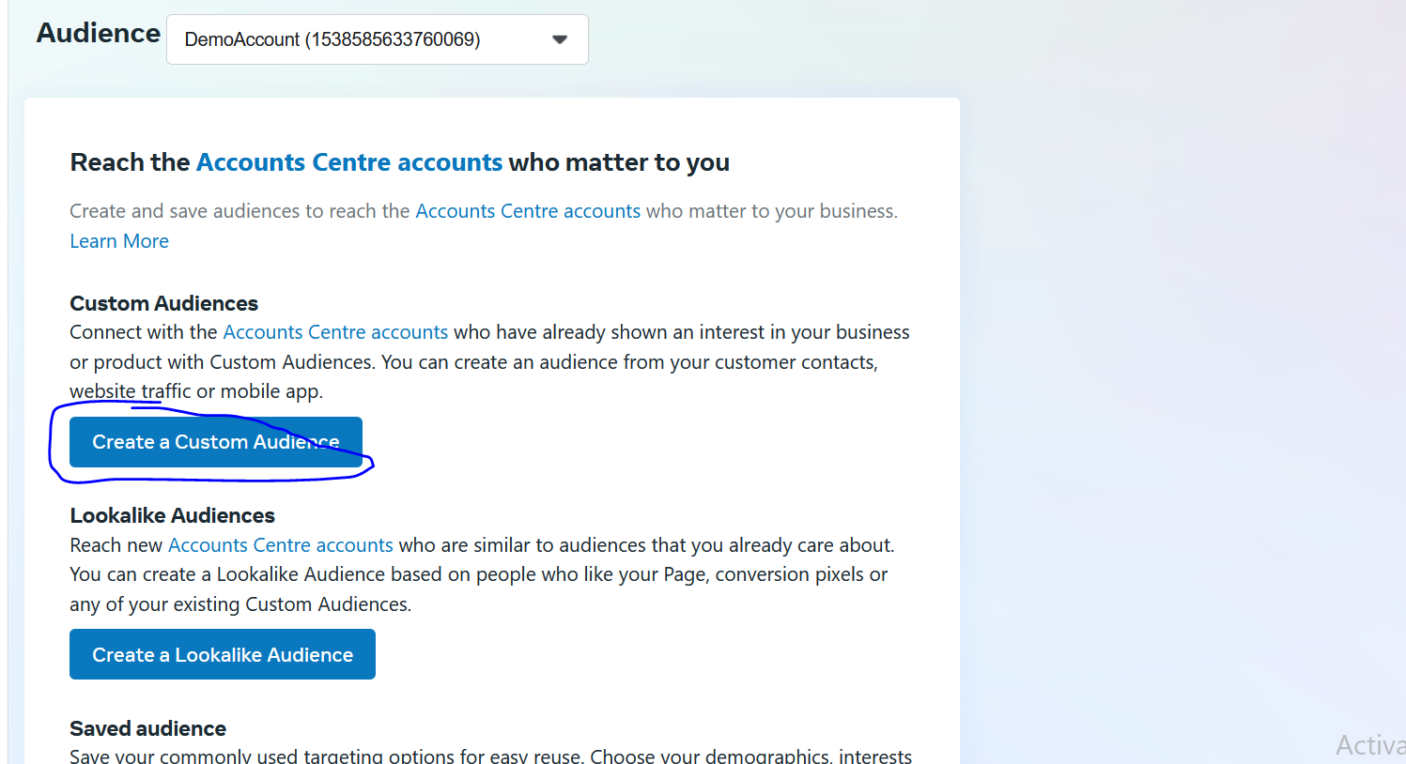

Click on Create ustom audience from marked above

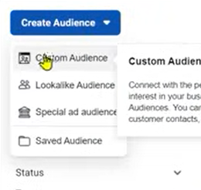

From teachers point of view it is giving submenu by clicking on them

We will click on custom audience option (From teachers pov)

Now you will get this panel in the center that is below

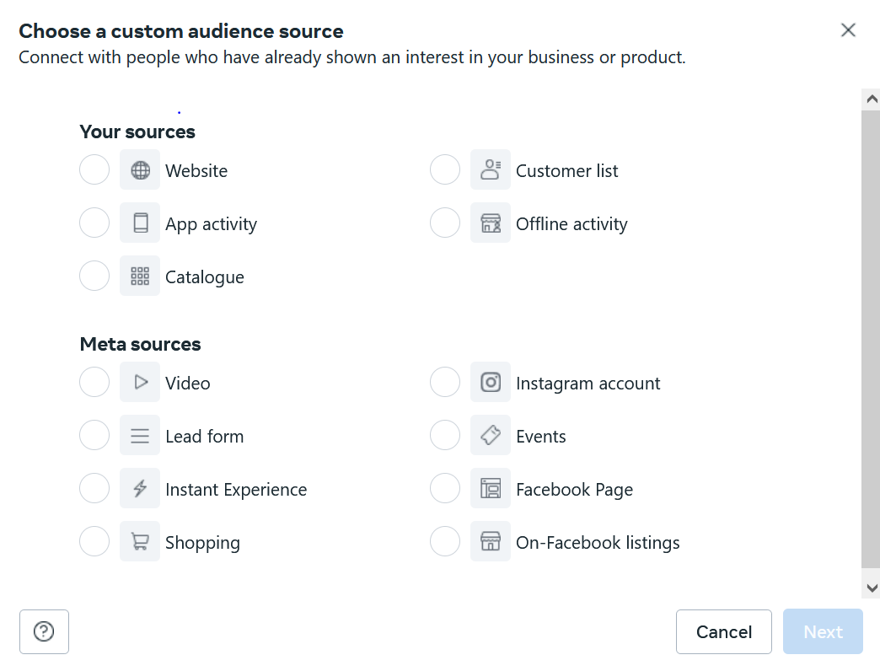

Now in above part it is showing Your sources and below it is showing Meta Sources

If I choose we bsite then we are createing custom audience on the basis of interaction on our website

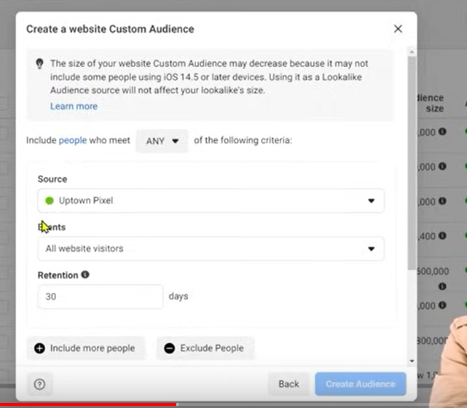

Now you can see there is an option of pixel is given(which is present in our website) in our source field

You can choose our pixels from here

You can even filter them if you choose event inside the event field you want to filter pixel about



In Meta sources you can see the option of videos that you uploaded in the platform

You can also see hrer option of instagram account , facebook page(People interacting with our page)

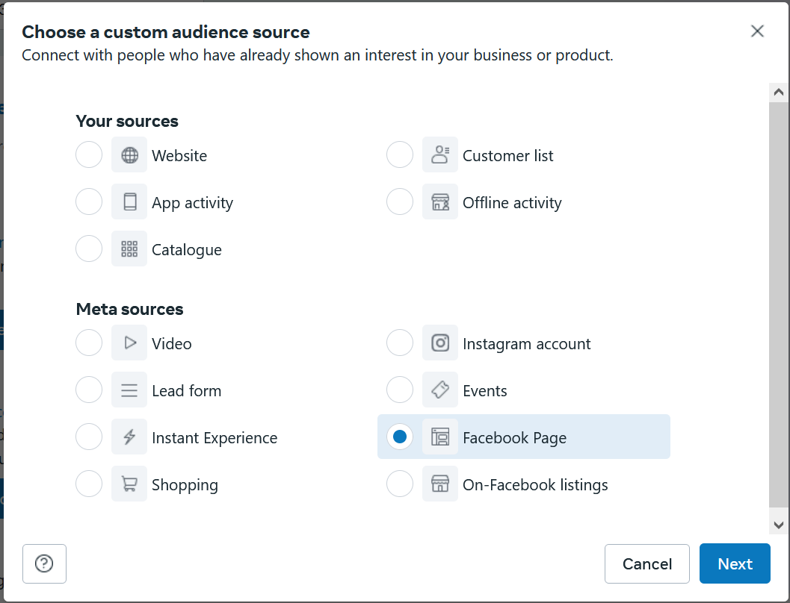

Now suppose we choose Facebook page and then click on next button and there is our Demo tutorial page is selected and in events fields you get a submenu which is shown below

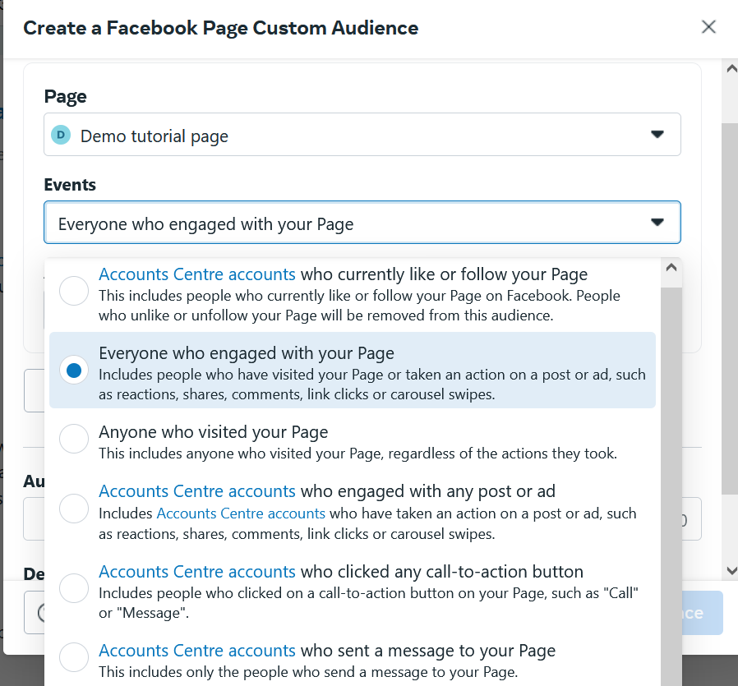

Here you get theoption of creating audiecen on the basis of people who engaged with your page,who like or follow your page, Anyone who visited our page,Who ingaged with any post and many as you can see above.

**Lesson 44:-**

In this lesson you will see How to create **custom audience on the basis of Videos**

To see in detail we need ot see some examples

Suppose we run an ad and in that we run the creative as video . Eventually with time when its reach will increase because of the view of the people we targeted

Maybe hter might be people who watched the video only twenty five percent , some 50 percent , some 75 percent

**Phase 57**

Or may be some people viewed the video 90 or 100 percent people but now if we want to make custom audience of percentage watched how we will do it in our ads account

We make audience of people who watched the ad 50 or 100 percent because we can use this audience in our other campaign and then show our ad to them in the sense of remarketing

So one condition is that we make audience according to percentage watched

Another condition is that sometimes we have a facebook page and we are regularly putting content inside it Now there are some videos inside it which become viral. And it get some good views So there on the basis of views

How much percentage of our video was watched. we make custom audience on the basis of iteven the video was organicI(video was uploaded in our page )

So what we are saying is that if our videos are becoming popular and people are watching our ad then we can make audience on the basis of it.

So this is normal we will show our ad again to those people

But if we make custom audience then

If we have custom audience tehn we can create lookalike audience of custom audience

By lookalike we mean suppose there were people who watched suppose 75 percent of the video so we say to the facebook that we want similar type of people in the form of audience

Remember the more the accurate custom audience the accurate lookalike audience we will have

Now suppose you have an audiecn who watched 75 percent of audience

And there is another audience who watched 90 percent of audience

Then tell which audience is more accurate

Ofcourse 90 percent

So if I make lookalike audience of it then our lookalike audience quality will be better

Now we will go to the window of custom audiences but we will choose video option this time

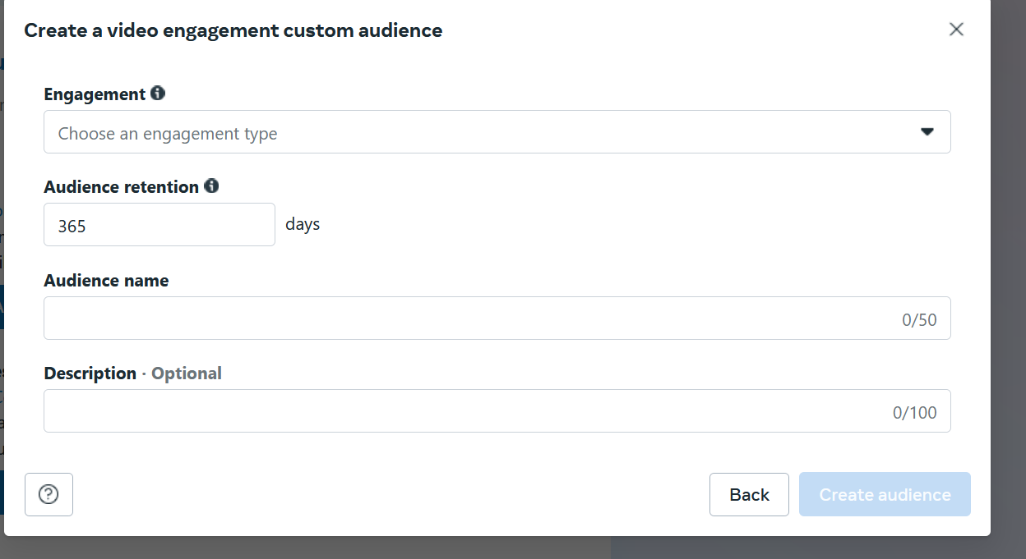

Now after clicking on the next then in the engagement field you will see a list telling on what type of engagement audience will be considered an audience

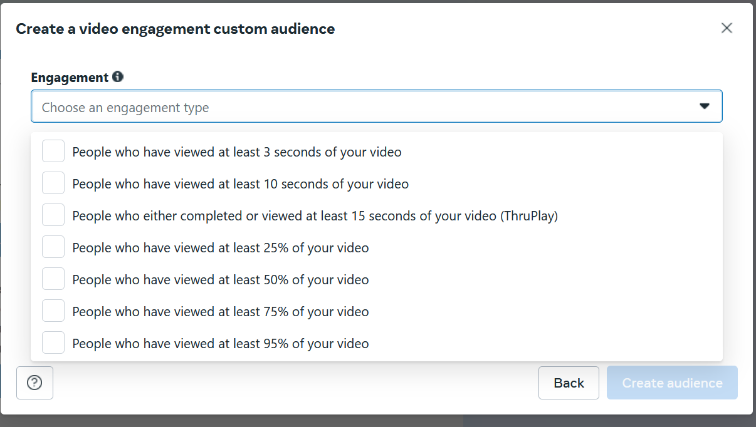

By clicking on it you will see lots of option

It also depend on the length of your video

We can say the audience who have seen more then 50 percent will be considered good or quality audience again it totally depends upon you what you select

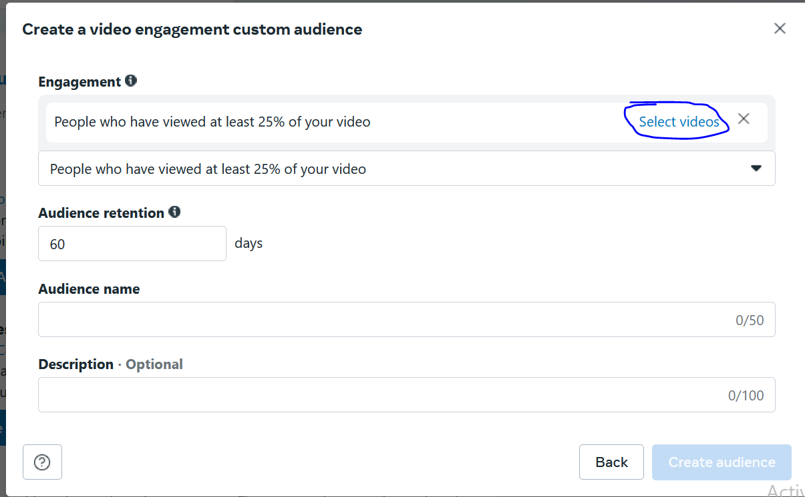

Now in retention choose the number of days the audience stays

Retention in Facebook ads can refer to audience retention or how long someone stays in a custom audience

In marked area when we click a window will be opened

Showing you sources from where you can select your video from

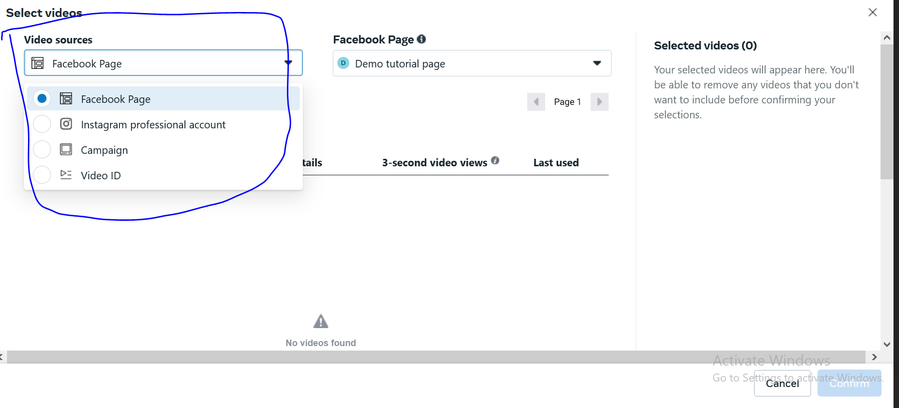

In marked you can see the sources that are Facebook page, Campaign Video, Instagram Professional account

We can also go with video id

Since we are new we will see from teachers perspective

We choose the videos and then confirm button



And then tell the audience name whatever you want and then click on create audience button

Now you can see your audience as shown below in the list of custom audience

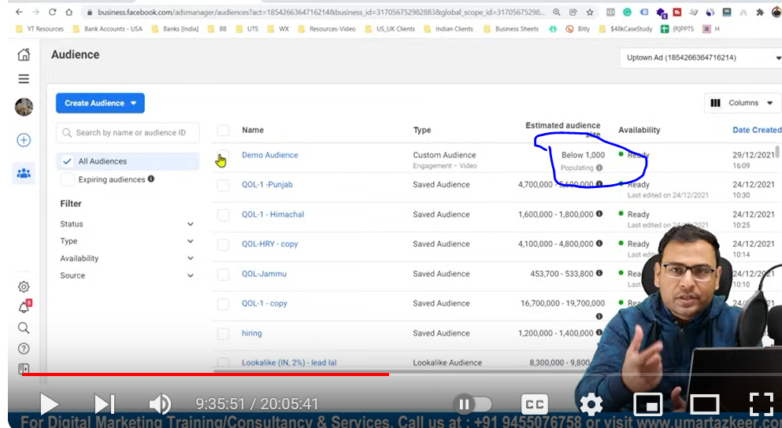

Gradually our audience will be populated as marked above then and then you can use this audience in any type of campaign you want

So now you can understand that the content we post on the basis of its engagement we have power or options to create custom audience but it totally depend on us how we are using it and

how we are able to think that on the basis of our content we are creating our custom audience

**Lesson 45:-**

In this audience we will learn about how to create **custom audience on the basis engagement or interaction on Instagram profile**

Suppose you have some business or public account then there might be peole wh like your post in your page, comment on it , save it and there might be people who see ads posted on your page

So these different different engagements or interaction on the basis of that how we can create custom audience

And that custom audience will made on the basis of that engagement which happened on our instagram profile.

No now in our custom audience creation window choose the Instagram account.

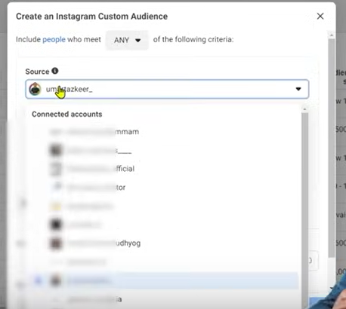

And then in sorces you see the list of all your instagram account , client accounts or whatever facebook profile you have access of.

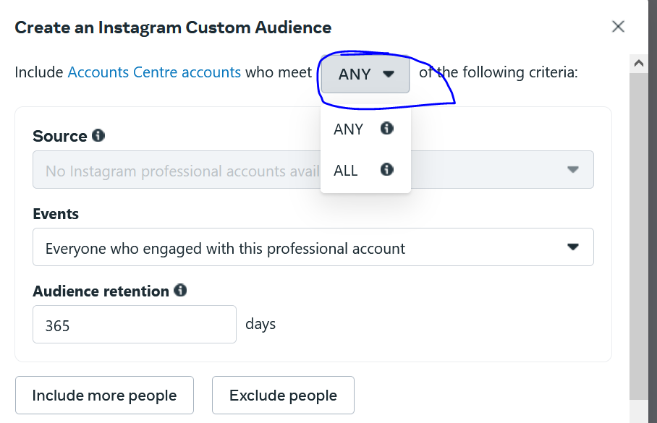

In marked area there is two option that is Any or All

What this means that if you choose all then the audience will include those people who fulfill all of the two condition or if any chosen then the audience will include those people who fulfill any of the two condition

Suppose if there was a condition specified that

1. View the page
2. Save the post

If any person view the page and then save its post tehen he will come under the audience but the person who view the page but not saved the audience then the audience will not be counted in custom audience this is a case of all

But if we have chosen any then above people would have come inside the custom audience

In that case our post has come into his viewer feed and he saved the post but not viewed our page then that person will come under our custom audiecen we created

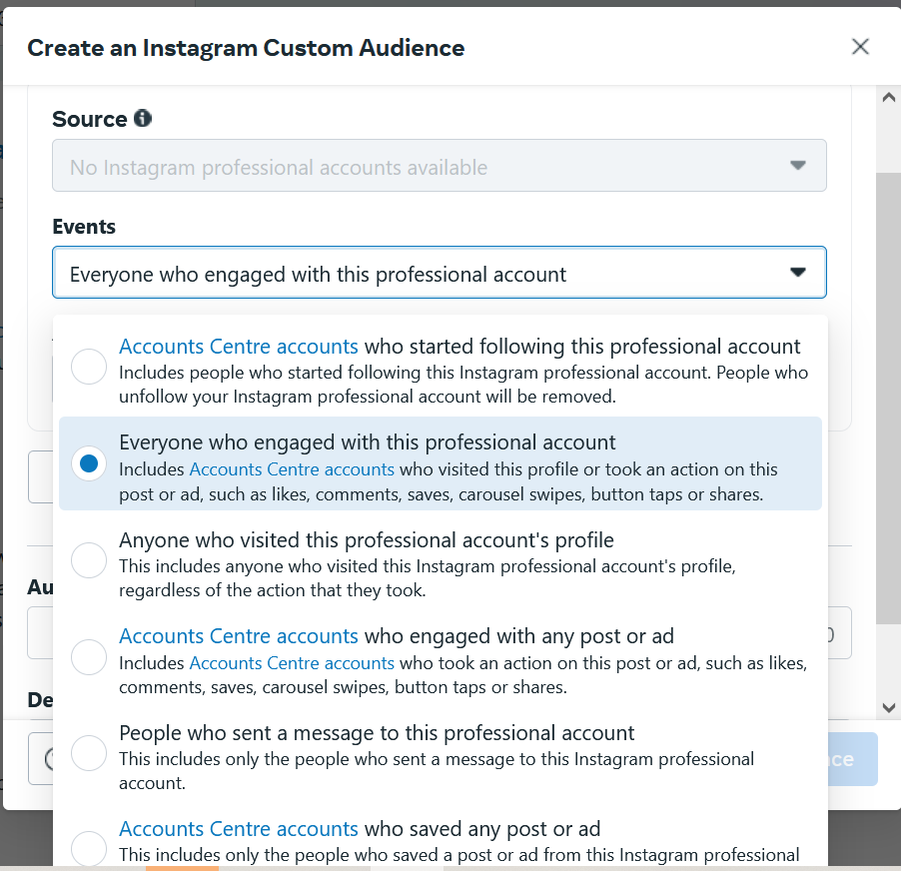

And then in vent field you get lots oprion as shown above(read it yourself)

Our first option is somewhat wide because it includes post, ad likes, comments, saves, carousal etc

We can also do so we can create different type of audience on the options given in events